* Below mentioned is the path to raise AHD with FS Central team;

**AHD Path: AHD->Financial service->Create new request->request area->FSBGV> Background Verification**

* Offshore To initiate BGV for offshore

**PFB List of Docs**.

* **Education Documents: (Clear & Uncut Scan copy)**

1.   Graduation and post-Graduation Mark sheets (all semesters) & Degree certificates/ Provisional certificate

* **Employment Documents: (Clear & Uncut Scan copy)**

1.   All Previous Service certificate \ experience letters from past employers for the last 5 years

2.   Infosys Offer Letter

* **Identification Documents: (Clear & Uncut Scan copy)**

1. Passport Copy or Pan card **(Self-attested-PDF Only)**
2. Infosys ID card **(front & Back)**

* **Letter of Authorization: (Clear & Uncut Scan copy) -**

1. **LOA** and **HSBC Consent Template** shown in below screenshot –Please provide digitally signed LOA and Consent form.Find the form in attachment.

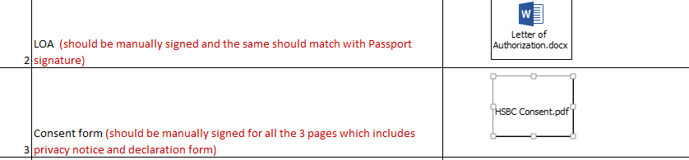

1. **BGV Form – Please fill it with complete and accurate details and upload the same in the AHd. (Don’t scan this document,)**



**How to attach the Docs in AHD**

1. Collate all docs in a folder. Zip/compress the folder.
2. Mail the zip folder to yourself, Subject line of the mail will be “**BG Checks need to be initiated**”,
3. Once you receive the mail save the mail and then attach that email to the AHD.
4. If the Folder size becomes> 10 MB, please divide the folder into 2 small folders with size<10 MB

Note: Mention in comment, **BG Checks need to be initiated for HSBC IVS**, Kindly share AHD no, Once done.

1. **Please Share the below docs with: -**

**To**: - [Deepak_Iyer@infosys.com](mailto:Deepak_Iyer@infosys.com),

**Cc**: - [vikas_gupta16@infosys.com](mailto:vikas_gupta16@infosys.com)

1. Profile as per attached sample templates in both the formats. This needs to be sent via an email.

**(Do not attach this doc in the AHD).**



1. DC Template, (Update Personal details highlighted in Yellow)This needs to be sent via an email

**(Do not attach this doc in the AHD).**



Let us know in case you face any issues with any of the document or have any queries:

Thanks…